







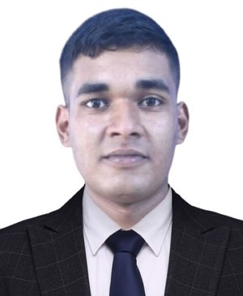
2022
To
2023

Higher Secondary Certificate
Cumilla Cadet College
GPA: GPA-5.00

EDUCATION
Bachelor of Science in Software Engineering
Daffodil International University
CGPA: Not yet published.

Secondary School Certificate
Cumilla Cadet College
GPA: GPA-5.00

2025
To
Present

2020
To
2021

d
d
d
Birulia, Savar, Dhaka, Bangladesh
Microsoft Office

Programming

Coding

Communication

Team Collaboration
Problem Solving
Leadership
CERTIFICATION
Mr. K. M. Shahriar Islam
Lecturer
Department of Software Engineering
Daffodil International University
E-mail: shahriar.swe@diu.edu.bd
Cell Phone: 01723021777

- National High School Programming Contest by ICT Division
- ICT Takeoff: Microsoft Office by Udemy
- Fundamentals of Digital Marketing by Google
- Public Speaking Fundamentals by a2i

www.linkedin.com/in/hasib2050
I have gained problem-solving experience through the Beecrowd Online Judge and was an active member of my college Computer Club. During my time at Cadet College, I participated in various science and class display projects and took part in Math and Physics Olympiads, which strengthened my analytical and logical thinking skills. Additionally, I have a few months of teaching experience as a private tutor, focusing on Math and Physics.
REFERENCE

Driven by a strong passion for programming and problem-solving, I aim to grow as a skilled software engineer and contribute to leading tech companies by building impactful and advanced technological solutions that improve everyday life.
253-35-645@diu.edu.bd
01864103655
EXPERIENCE

CAREER OBJECTIVE

LANGUAGE
Bangla
English
Hindi
MD. HASIBUL HASAN HASIB
B.Sc. in Software Engineering
SKILL
CONTACT

